A close up of a logo



Dynamics 365 Customer Insights

**Lab 4A: Data Ingestion, Unification, Relationships & Measures**

**Contents**

Lab Scenario: Contoso Coffee 4

Module Introduction 7

Familiarize yourself with Customer Insights 8

Exercise 1 - Data Ingestion 11

Data Sources 11

Data Source Model 12

Task 1 – Ingest Customer Data from eCommerce Platform 13

Task 2 – Ingest Online Purchase Data 17

Task 3 – Ingest Customer Data from Loyalty Scheme 19

Task 4 – Ingest Customer Data from Point of Sale Purchases 22

Task 5 – Ingest Customer Data from Website Reviews 25

Exercise 2 - Data Unification 28

Task 1 – Map contacts to common data types 28

Task 2 – Specify Match Order 31

Task 3 – Create a Match Rule 32

Task 4 – Precision 34

Task 5 – Merge 37

Exercise 3 – Creating Relationships and Measures 39

Measures 39

Task 1 – Define the Relationship Between Unified Profiles and Web Purchases 41

Task 2 – Define the Relationship between Unified Profiles and Store Purchases 42

Task 3 – Define Two Business Measures 43

Average Store Purchase Value (Business Measure) 43

Average Web Purchase Value (Business Measure) 46

Task 4 – Define Customer Measures 49

Total In-Store Spend (Customer Measure) 49

Task 5 – Define Customer Attributes 51

Task 6 – Review the Measures 55

# About the Hands-on Lab

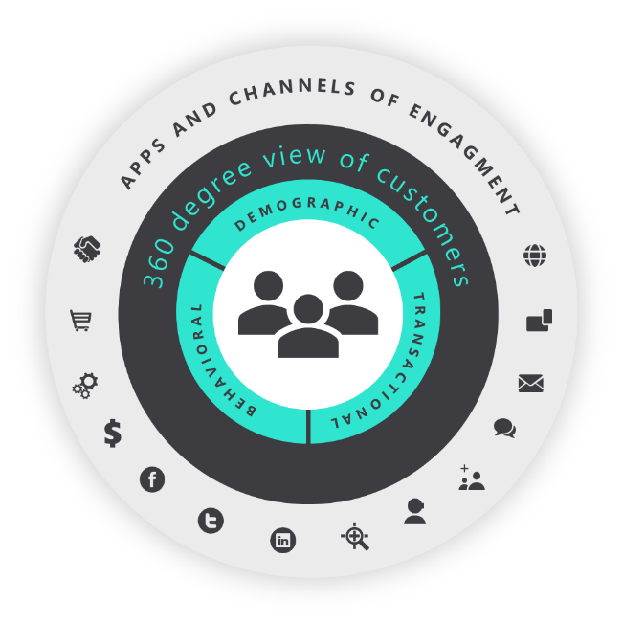  
Unlike traditional approaches for realising a 360-degree view of the customer with a large amount of coding involved, Dynamics 365 Customer Insights (CI) is a finished SaaS solution which allows you to adopt an agile project management approach and deliver value in a matter of weeks.

By attending this Hands-on Lab, you will learn step-by-step how to set up, configure and use Dynamics 365 Customer Insights. To bring this to life, we are looking at a typical customer analytics project for our example company, Contoso Coffee.

We will introduce the business pain points, goals and high-priority use cases that Contoso has identified around their customer data initiative, and then realise a working prototype solution today.

# Lab Scenario: Contoso Coffee

Contoso Coffee produce high-quality coffee and coffee machines, which they retail through channels including new Contoso Retail Stores in premium locations, premium food resellers and the Contoso Coffee Web Site.

Contoso plan to further expand their offerings with Contoso Cafés and a new Connected Coffee Machine which can trigger refill orders and alert Contoso service about any issues.

This new offering will help them to build direct relationship with their customers and learn more about how customers consume their products

## Business Objective

Contoso wish to own and build a meaningful, direct relationship with all consumers to deliver an exceptional, personalised customer experience through relevant communications, personalised recommendations, and services.

**Increase customer attraction and retention by making customers feel valued through experiences that customers love.**

## Challenges

#### Transactional Relationship

Their existing business model means that they lack a direct relationship with their customers.

#### Data Silos

They are unable to deliver personalised customer experiences.

## Existing Data Landscape

Fractured Customer Data

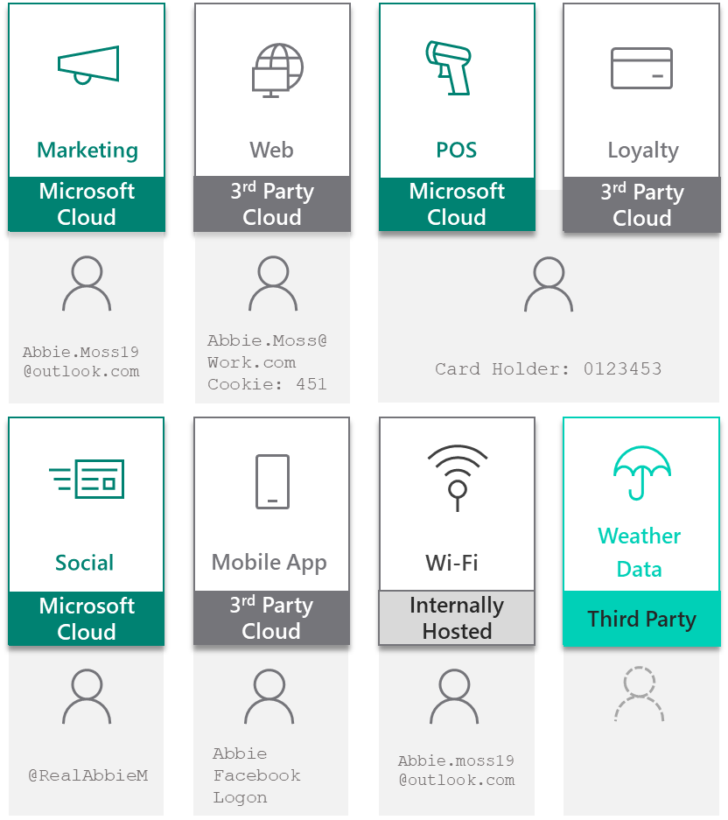With multiple systems, Contoso has multiple records for the same person. This causes a disjointed experience to the customer who expects to be treated as one person regardless of the channel they are transacting upon.

Multiple Platforms

The architecture at Contoso has evolved through acquisition and legacy systems meaning that data can reside in not only different systems, but different platforms across multiple clouds and on premise.

Non-Customer Data

Contoso are drawing correlations between non-customer data and the impact it has on customer experiences, including data from third parties such as weather data.

## Contoso Coffee Customer Insights Project

Contoso management is tasking IT and Line of Business teams with the following:

* Establish a customer data hub combining all customer related data from siloed sources.
* Realise a unified Contoso Customer profile.
* Provide a 360-degree view of the customer for service agents (embedded into D365 for Service) as well as store managers (through Power BI)..
* Deliver a Contoso Coffee Greeter App (through PowerApps), to enable in store retail staff to deliver personalised service and recommendations.
* Automate various business processes like email alert when customers churn rate surges using Power Automate.

## Contoso Coffee Customer Insights Project

You have been selected as the project manager for the implementation of Dynamics 365 Customer Insights at Contoso Coffee. As an experienced project manager, you devise the following plan:

1. Create a Customer Insights environment
2. Ingest data from highest priority data sources from within the business
   1. Point-of-Sale (POS)
   2. Loyalty Data
   3. Ecommerce Customers and Web Purchases
   4. Subscription data (optional and will happen in the intelligence module lab)
   5. Dynamics 365 CRM (Will be done in the Dynamics module labs)
   6. Contoso Hotel data (Optional and will be done in the Advanced module lab)
3. Configure and realise a unified customer profile from ingested data
4. Configure business and customers measures in Customer Insights to identify customers with higher than average spend in store and online.
5. Build sample customer segments for Marketers to deliver personalised and targeted marketing communications
6. Configure Customer Insights contact cards and embed into Dynamics 365 to empower Contoso Customer Service Advisors
7. Create Power BI dashboard for Store Managers
8. Create Greeter App with PowerApps for Contoso Coffee retail staff, empowering them to deliver personalised service
9. Use Microsoft Power Automate to capture Customer check ins at Contoso retail stores and deliver personalised recommendations to Contoso Retail staff
10. Demo Customer Insights prototype to group of pilot users and gather feedback

# Module Introduction

## Lab pre-requisites:

Before you can start this exercise, you must have completed Lab 3 to setup your environment.

## Data Ingestion & Unification

As Project Manager for Contoso Retail, you will create a unified customer profile by ingesting key sources of customers data and following the Map, Match and Merge process.

## Creating Relationships

You will create different kinds of relationships to help join the different datasets together which help support other areas of Customer Insights which use these relationships to traverse the data sets.

## Measure Calculation

You will calculate previously unobtainable key Business and Customer KPIs including  
Lifetime Spend, Club Points Balance, Average in Store and Average Online Purchase values.

## Objectives

* Ingest siloed data sources
* Follow Map, Match and Merge to create a Unified Profile
* Create the required Relationships between data sets
* Create the Measures (KPIs) we want to track

## Approximate Time to Complete – 90mins

# Familiarize yourself with Customer Insights

In this task, you will explore the pre-configured **Demo** environment to familiarize yourself with Customer Insights Hub.

1. Sign-into Customer Insights at <https://home.ci.ai.dynamics.com>
2. In the *Environment* selector in the top right-hand corner, select the **Demo** Environment

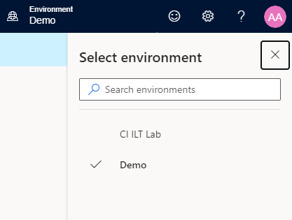

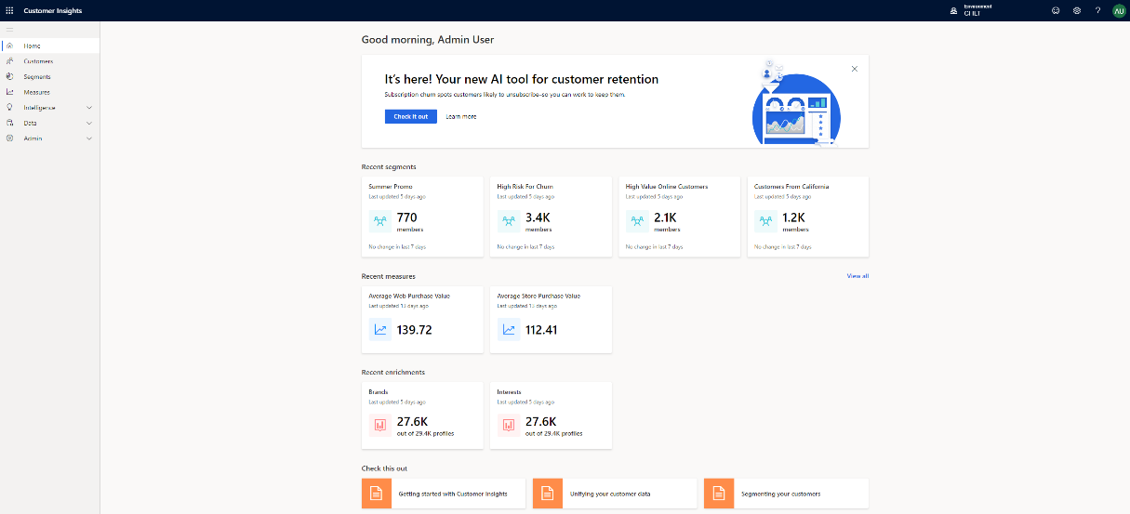

1. On the Home Page, note how the key **Insights** are highlighted:

* **KPIs** (Business Measures), including Average Online Spend Per Customer and Average Churn Score.

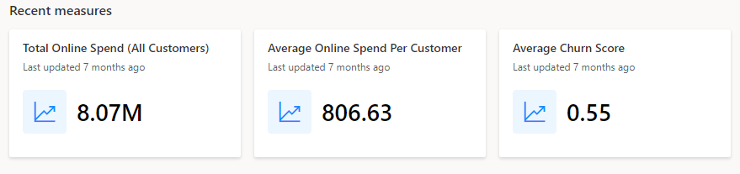

* **Audience Enrichment** pulled in from Microsoft proprietary data (including Microsoft Bing). Enrich Customer Profiles and Audience segments to unlock affinities for brands and interest categories that may be like your customers, by matching demographic data.

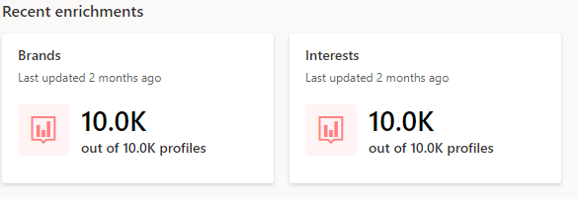

* **Segments** - customers grouped into cohorts based on demographic, transactional, or behavioural customer attributes. Using segmentation, you can target promotional campaigns, sales activities, and customer support actions to achieve your business goals.

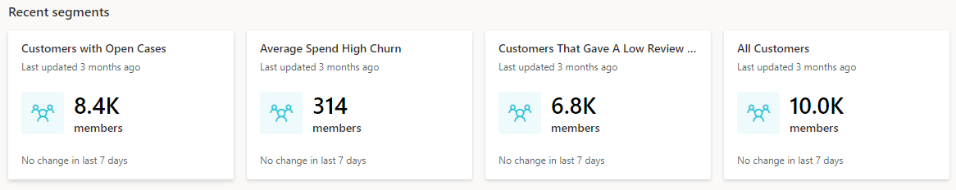

* **Check this out:** links to Customer Insights documentation and help on core topics such as data ingestion, Map, Match and Merge and Segmentation

A picture containing screenshot



1. Explore the left-hand menu options to familiarise yourself with the navigation.

**Home:** Home Page

**Customers:** View cards for unified Customer Profiles

**Segments:** Define Segments: Cohorts of Customers based on similar demographic, transactional or behavioural attributes. Use these for targeted marketing, utilising previously siloed data.

**Measures:** Define key Business and Customer KPIs.  
Such as Customer Lifetime Value, Average Purchase Value and Frequency, CSAT and identify high-value customers.

**Intelligence:** Here you can leverage the existing Out of the Box (OOB) models or add custom Azure machine learning models to make predictions with your unified customer data

**Data**: Ingest siloed demographic, transactional of behavioural data. Map, match and merge into a Unified Customer Profile. View your entities and define activity types and their relationships to your customers.

**Enrichment:** Go beyond your unified profile and enrich customer profiles with Microsoft Proprietary Data from the Microsoft Graph. Unlock data on affinities for hundreds of brands and dozens of interest-categories. These affinities are extracted for profiles that might be like your customers.

**Admin:** Administer Roles, Permissions, APIs and Export Destinations for Customer Segments.

# Exercise 1 - Data Ingestion

In this lab you will become familiar with ingesting data from multiple sources. As Project Manager for Contoso Retail, you have already identified that key sources of data include eCommerce Customers, Online Purchases, in-store Point of Sales Purchases, data from Contoso Retail Loyalty Card scheme, Subscription data, Contoso Hotel data­­­­ and Contacts from your Dynamics 365 CRM.

Although Customer Insights has connectors to 35+ data sources and applications (including Dynamics 365 & the Common Data Service for Apps), for this lab you will be using the ‘Text/CSV’ connector.

## Data Sources

|  |  |  |
| --- | --- | --- |
| **Entity** | **Description** | **Connection** |
| **eCommerceContacts** | Extract of Customers who have made an online purchase | https://aka.ms/CI-ILT/Contacts |
| **LoyaltyScheme** | Extract of Customers who’ve signed-up for the Contoso Retail Loyalty Card Scheme | https://aka.ms/CI-ILT/LoyaltySchemeCustomers |
| **OnlinePurchases** | Extract of purchases made via the Contoso Retail Website | https://aka.ms/CI-ILT/OnlinePurchases |
| **POSPurchases** | Extract of in-store purchase detail | https://aka.ms/CI-ILT/POSPurchases |
| **WebsiteReviews** | Online Website Reviews from online users | https://aka.ms/CI-ILT/WebReviews |

## Data Source Model

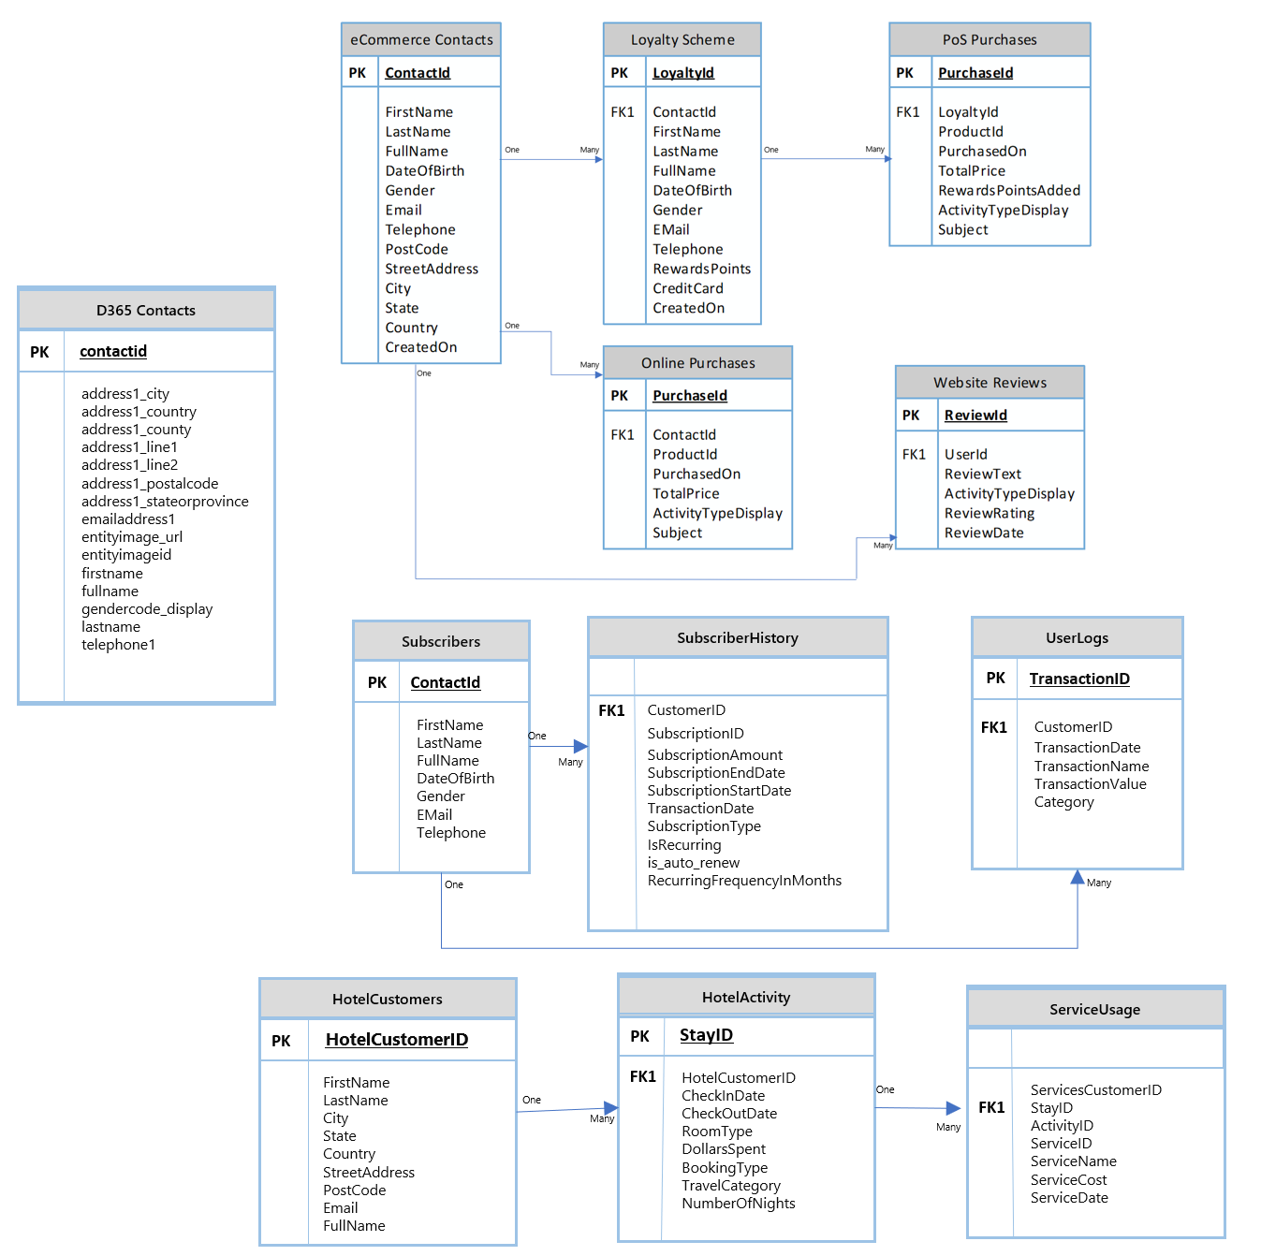

Note: Some of this data will be ingested in later labs

## Task 1 – Ingest Customer Data from eCommerce Platform

1. Sign-in to Customer Insights (<http://home.ci.ai.dynamics.com>) and select your Environment from the drop-down in the top right-hand corner. 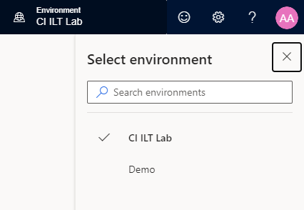
2. Within Customer Insights, expand **Data** on the left menu and click **Data Sources**
3. Click **Add Data Source**, then choose from the available methods of ingesting data. Currently, CI provides import data via various data connectors, connect to your own data lake, connect to Common Data Service. For this lab, choose **Import data** and name the source **eCommerce**, then click **Next button**

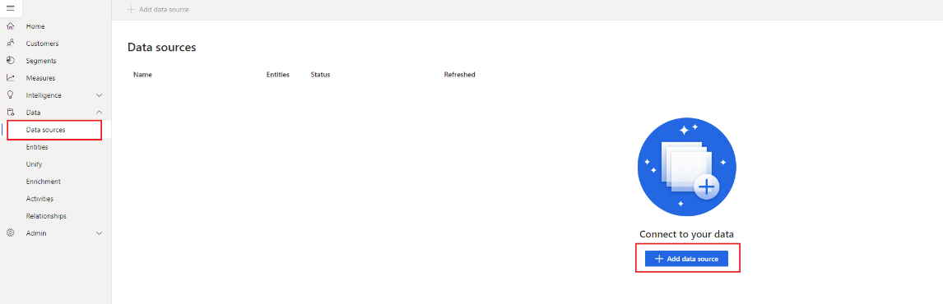

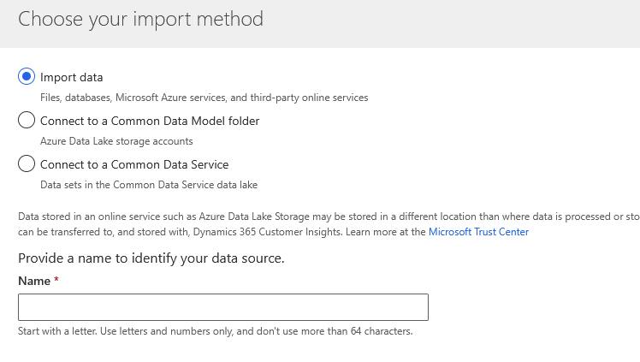

1. You will be presented with a view of data source connectors that Customer Insights is able to ingest. Take note of the connector types available, including *Common Data Service for Apps*. Select the **Text/CSV** Connector.

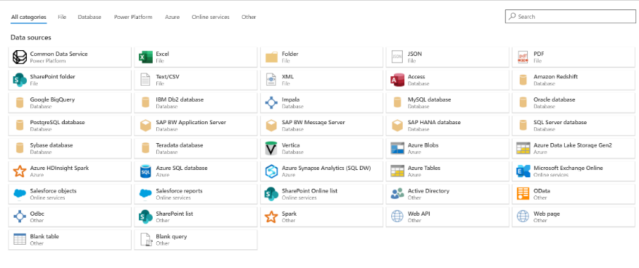

1. Enter the URL for eCommerce Contacts data set, **https://aka.ms/CI-ILT/Contacts**, and click **Next**.  
   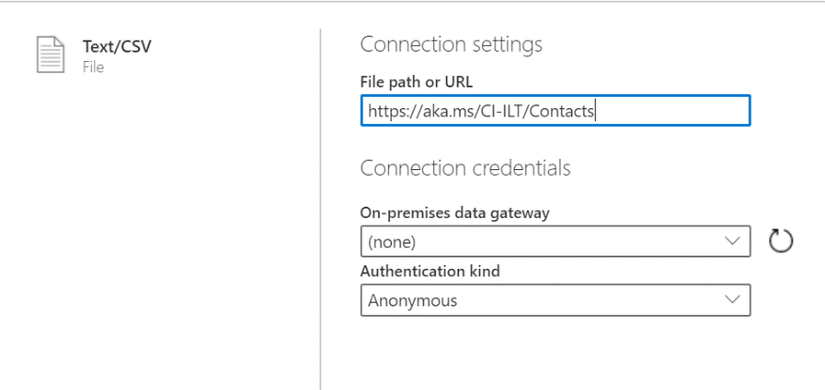
2. You should now see the data from the source tabulated. Click **Transform data** to configure the datatypes and formats for the data you ingest. 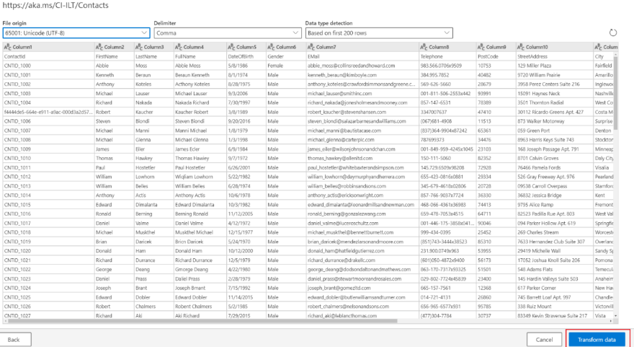
3. You will notice that the column heading has appeared in the first row of the data. To correct this, click **Transform** and **Use first row as headers.**

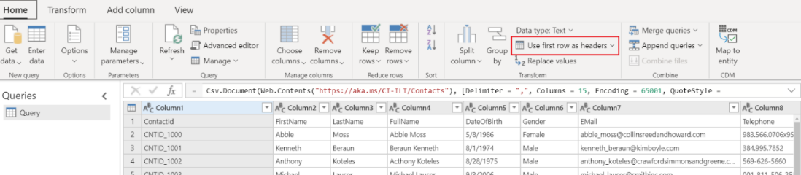

1. Because we have ingested data from a Text/CSV source, all columns have been defaulted to a ‘Text’ Data Type. To successfully ingest and model the data, we can set the datatype for non-text columns.

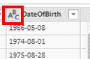  
To change the datatype, click the **ABC** icon within the column heading. Update the datatype for the columns listed below.

|  |  |
| --- | --- |
| **Column Heading** | **New Data Type** |
| DateOfBirth | Date |
| CreatedOn | Date |
| Income | Currency |

1. In the ‘Name’ field on the right-hand pane, rename your data source from **Query** to **Contacts** and hit **Next.** Click **Save**.

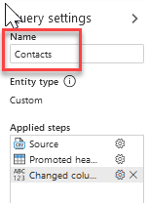

Congratulations! - You have now successfully created your first data source with a data set!

**Note:** Column names can only contain letters, numbers, and underscores. They cannot contain a space and must begin with a letter. If you have data where column name(s) have a space or do not begin with a letter you will want to fix that either within Power Query or before the data is brought into Customer Insights.

As we talked about in the session, a data source can contain more than one data set to help group data sets that have a relationship together. In this case because we have two data sets from the eCommerce site, we will group them into the same data source.

While you are still in the Power Query screen for the **eCommerce : Contacts** data set let’s click the **Get Data** button in the ribbon bar to add another data set to this same **eCommerce** data source.

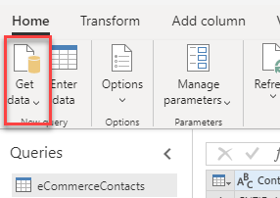

We’ll continue importing the next data set in the next task.

## Task 2 – Ingest Online Purchase Data

In this next task, we will ingest Online Purchase data, representing purchases made via the Contoso Coffee website. If you have just completed the previous task, skip to step 4.

1. Within Customer Insights, expand **Data** on the left menu and click **Data Sources**
2. You should see your **eCommerce** data source. Select it and click either the three vertical dots and choose **Edit** or click directly on the pen icon**.**

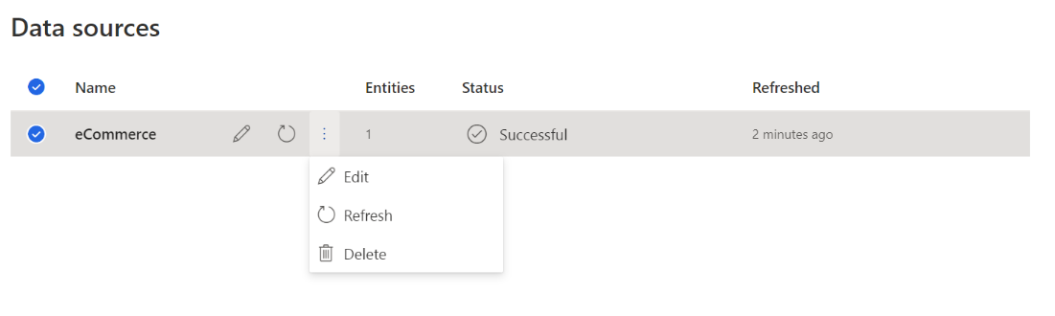

1. You should be presented with the view of the eCommerce Contacts data that you ingested in Task 1. In the action menu, click **Get Data.**

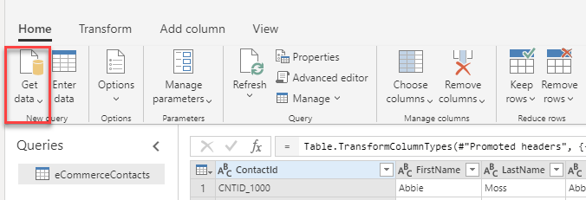

1. You will be presented with a view of data source connectors that Customer Insights is able to ingest, select the **Text/CSV** Connector.
2. Enter the URL for the **Online Purchases** data, **https://aka.ms/CI-ILT/OnlinePurchases**, and click **Next** and then **Create.**
3. As you did in Task 1, click on **Use first row as headers** or you can click on **Transform** tab and click **Use first row as headers.**

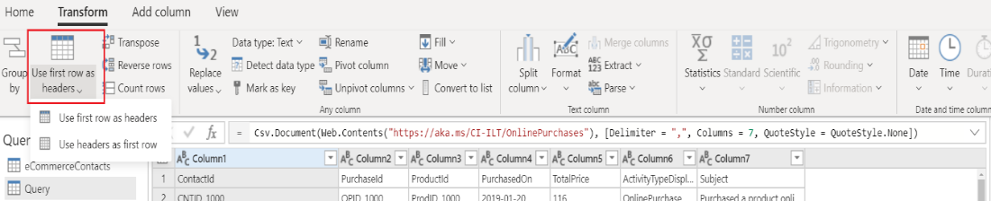

Once complete, update the datatypes for the following columns

|  |  |
| --- | --- |
| **Column Heading** | **New Data Type** |
| PurchasedOn | Date |
| TotalPrice | Currency |

1. Name your query **Purchases** and click **Save.**

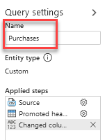

## Task 3 – Ingest Customer Data from Loyalty Scheme

1. Within Customer Insights, expand **Data** on the left menu and click **Data Sources**
2. Click **Add Data Source**, then choose from the available methods of ingesting data. Currently, CI provides import data via various data connectors, connecting to your own data lake, or connecting to the Common Data Service. For this lab, choose **Import data** and click **Next** and name the source **Loyalty**, then click **Next.**

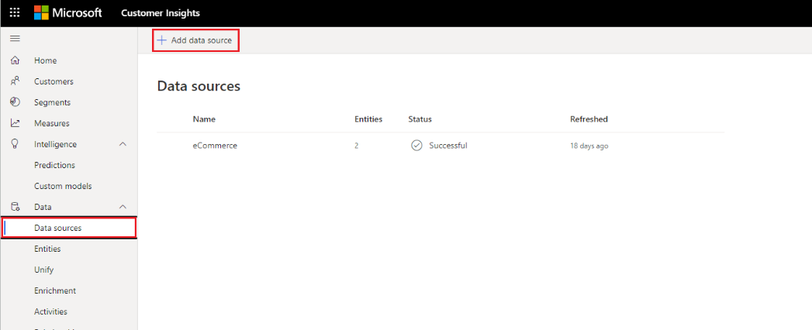



1. You will be presented with a view of data source connectors that Customer Insights is able to ingest. Take note of the connector types available, including *Common Data Service*. Select the **Text/CSV** Connector.

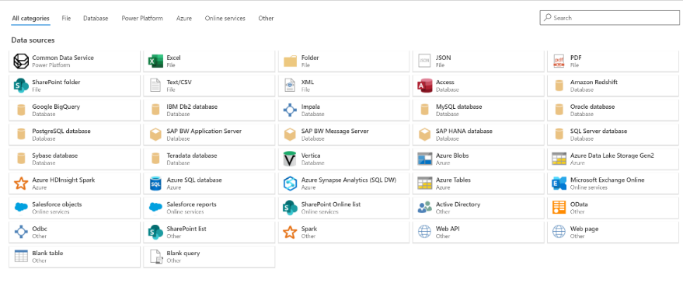

1. Enter the URL for the Loyalty Customer data, **https://aka.ms/CI-ILT/LoyaltySchemeCustomers** and click **Next** and click **Transform data**.  
   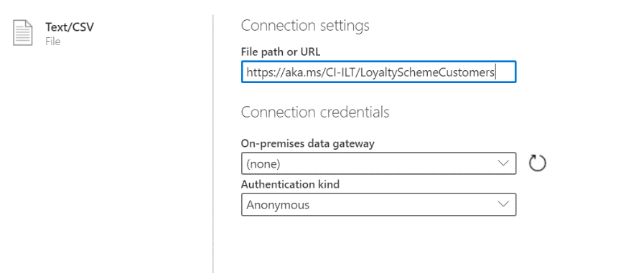
2. You should now see the data from the source tabulated. Here you can configure the datatypes and formats for the data you ingest.   
     
   You will notice that the column heading has appeared in the first row of the data. To correct this, click **Transform** and then **Use First Row as Headers** or click it directly from the **Home** tab**.**

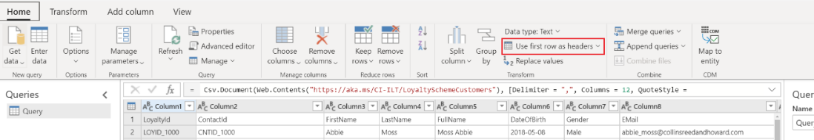

1. Because we have ingested data from a Text/CSV source, all columns have been defaulted to a ‘Text’ Data Type. To successfully ingest and model the data, we can set the datatype for non-text columns.

  
To change the datatype, click the **ABC** icon within the column heading. Update the datatype for the columns listed below.

|  |  |
| --- | --- |
| **Column Heading** | **New Data Type** |
| DateOfBirth | Date |
| RewardPoints | Whole Number |
| CreatedOn | Date |

1. In the ‘Name’ field on the right-hand pane, rename your data source from **Query** to **Customers** and click **Save**.

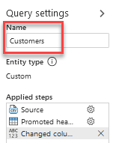

## Task 4 – Ingest Customer Data from Point of Sale Purchases

1. Within Customer Insights, expand **Data** on the left menu and click **Data Sources**

Click **Add Data Source**, choose **Import data** and name the source **PoS**, then click **Next**

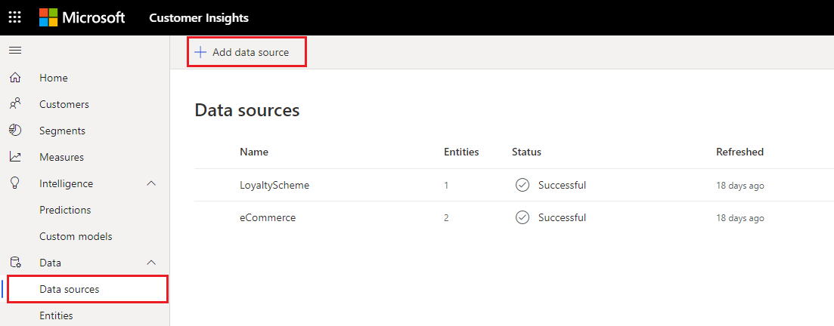



1. You will be presented with a view of data source connectors that Customer Insights is able to ingest. Take note of the connector types available, including *Common Data Service*. Select the **Text/CSV** Connector.



1. Enter the URL for the Point of Sale Purchases, **https://aka.ms/CI-ILT/POSPurchases**, and click **Next** and click **Transform data**  
   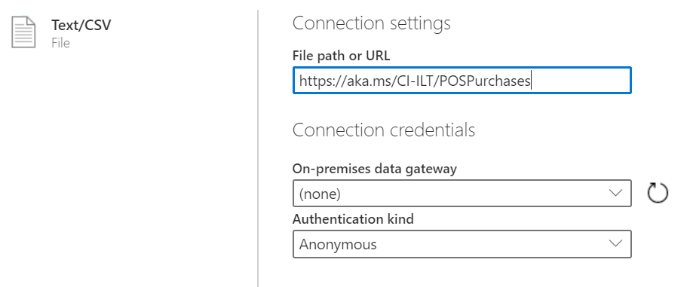
2. You should now see the data from the source tabulated. Here you can configure the datatypes and formats for the data you ingest.   
     
   You will notice that the column heading has appeared in the first row of the data. To correct this, click **Use First Row as Headers** from Home or click **Transform** and then **Use First Row as Headers.**

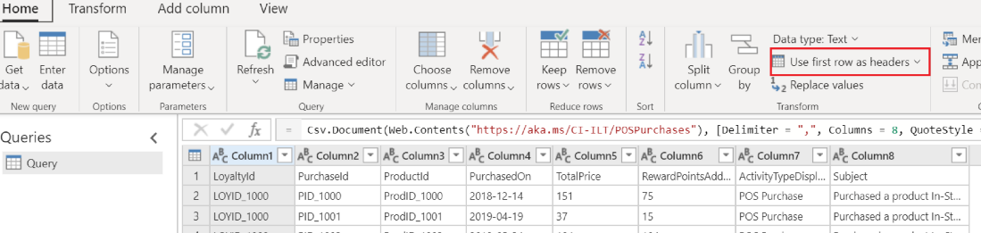

1. Because we have ingested data from a Text/CSV source, all columns have been defaulted to a ‘Text’ Data Type. To successfully ingest and model the data, we can set the datatype for non-text columns.

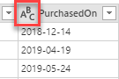  
To change the datatype, click the **ABC** icon within the column heading. Update the datatype for the columns listed below.

|  |  |
| --- | --- |
| **Column Heading** | **New Data Type** |
| PurchasedOn | Date |
| TotalPrice | Currency |
| RewardPointsAdded | WholeNumber |

1. In the Name field on the right-hand pane, rename your data source from **Query** to **Purchases** and click **Save.**

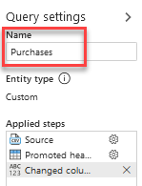

## Task 5 – Ingest Customer Data from Website Reviews

1. Within Customer Insights, expand **Data** on the left menu and click **Data Sources**
2. Click **Add Data Source**, choose **Import data** and name the source **Website**, then click **Next.**

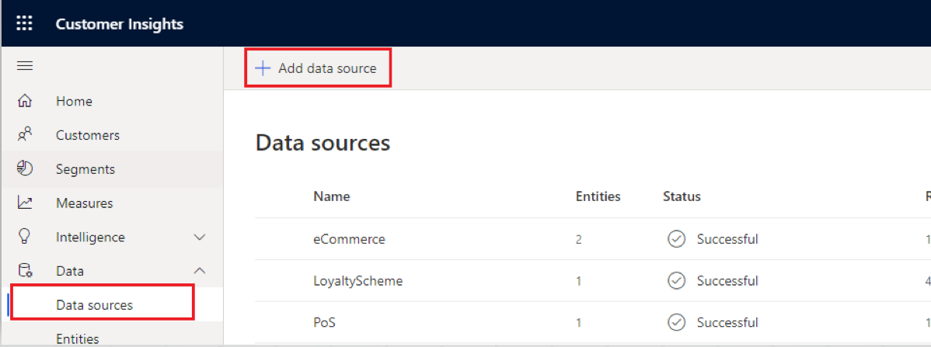



1. You will be presented with a view of data source connectors that Customer Insights is able to ingest. Take note of the connector types available, including *Common Data Service*. Select the **Text/CSV** Connector.



1. Enter the URL for the Website Reviews, **https://aka.ms/CI-ILT/WebReviews**, click **Next** and then click **Transform data**.  
   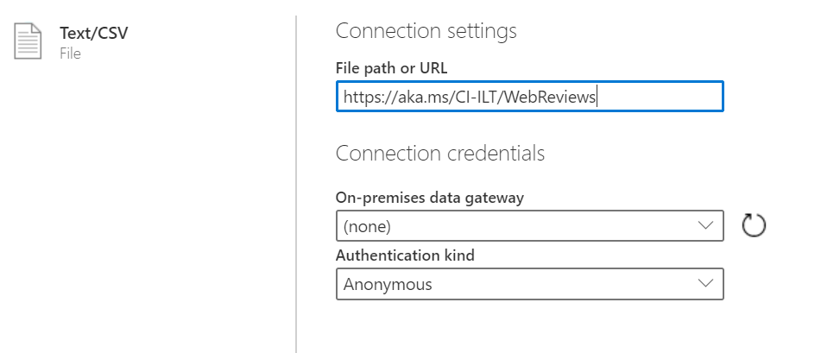
2. You should now see the data from the source tabulated. Here you can configure the datatypes and formats for the data you ingest.   
     
   You will notice that the column heading has appeared in the first row of the data. To correct this, click **Use First Row as Headers** from Home or click **Transform** and then **Use First Row as Headers.**

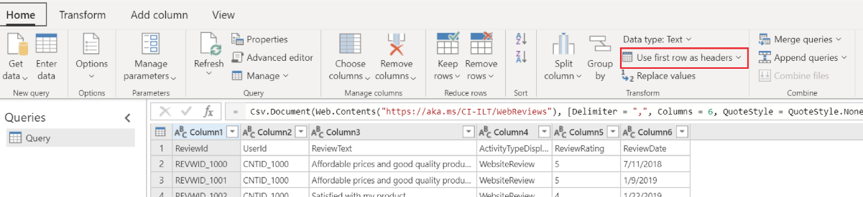

1. Because we have ingested data from a Text/CSV source, all columns have been defaulted to a ‘Text’ Data Type. To successfully ingest and model the data, we can set the datatype for non-text columns.

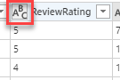  
To change the datatype, click the **ABC** icon within the column heading. Update the datatype for the columns listed below.

|  |  |
| --- | --- |
| **Column Heading** | **New Data Type** |
| ReviewRating | Whole Number |
| ReviewDate | Date |

1. In the **Name** field on the right-hand pane, rename your data source from **Query** to **Reviews** and click **Save**.

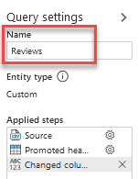

# Exercise 2 - Data Unification

Having ingested the raw data from your data sources into entities you will now begin the **Map, Match, Merge** process to create a single **Unified Customer Profile** by merging data from each customer profile source.

To do this you will first map your ingested entities against a standard model and select the Primary Key for each of your profiled entities. Following the completion of this you will then create your **Match Rule** that will be used to match contacts from all customer entities.

Finally, running the **Merge** process will create a single set of unique **Customers** having matched profiles from all customer entities using your match rules.

Your objective is to find out how many unique customer profiles Contoso Retail has across various data sources.

## Task 1 – Map contacts to common data types

1. Map contacts from eCommerce and Loyalty data to common data types.

In the left menu click **Unify -> Map -> Select Entities**

Select the entities that represent the customer profile – **Contacts (eCommerce)**, **Customers (Loyalty)** then click **Apply**

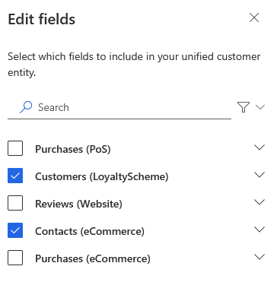

1. You will now be presented with the mappings of your source entity against standard model types. You can review the types in the table.

You must choose a ‘Primary Key’ for each entity you have ingested. The primary key must be a unique reference. For **eCommerce Contacts** select **ContactId** as the Primary Key.

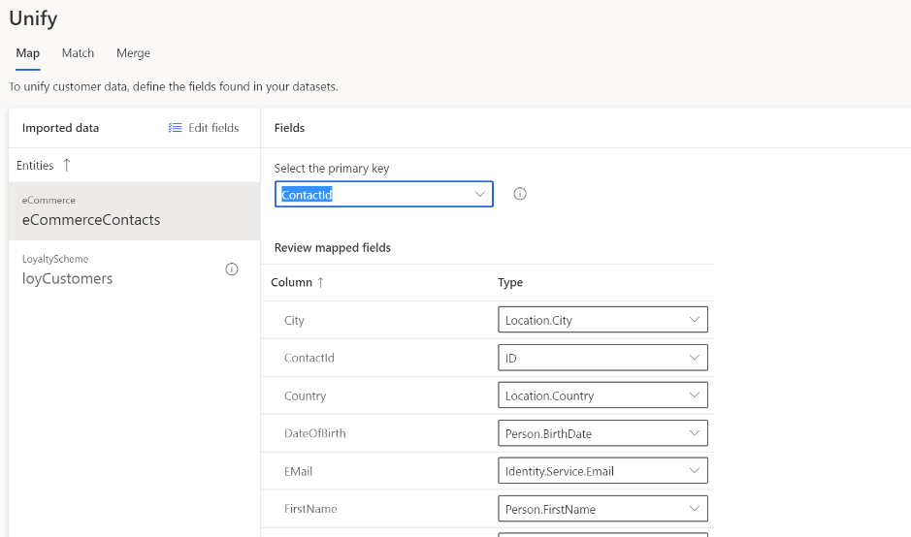

1. Our **eCommerce Contacts** data contains a column named **Email Subscriber** which will be mapped to an incorrect type, *Identity.Service.Email* because of the name. Open the dropdown for this field and select the empty option (nothing/blank). If we do not do this then the system default to merging this field with the Email fields which we do not want. You will also need to do this for **Income** which may get mapped to *Identity.Service.Phone*

1. Select **Loyalty Customers** under ‘Entities’ and set **LoyaltyID** as the Primary Key.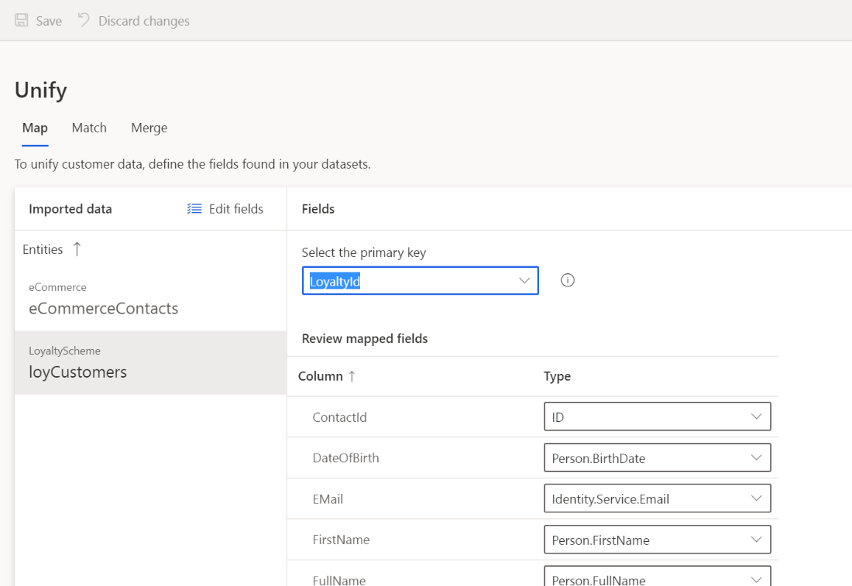
2. Our **Loyalty** data contains a column named **RewardPoints** which will be mapped to an incorrect type, *Measurement.Duration* because of the name/type. Open the dropdown for this field and select the empty option (nothing/blank).
3. Then click **Save** in the top left-hand corner.
4. Click **Match**

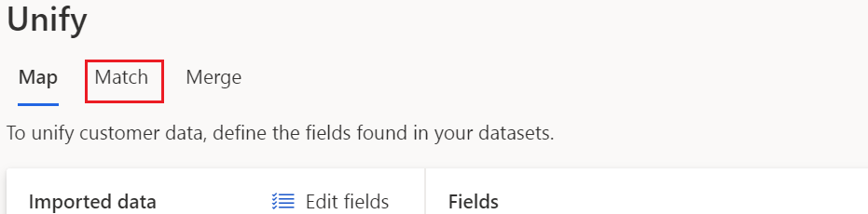

## Task 2 – Specify Match Order

For the next stage, we must select the order in which to merge the profiles. You will be able to merge attributes to ensure that the unified profiles are complete as well as the priority of which sources to use for those attributes.

1. If you haven’t already, Click **Match** in the top menu on the page.



1. You should select the most complete or accurate profile source as the Primary.  
   Click **Match à Set Order**
2. In the **Primary** drop-down list select **Contacts : eCommerce** as the primary Source and choose to **Include all records**
3. In the **Entity** **2** drop-down list select **Customers : Loyalty** and choose to include all records.

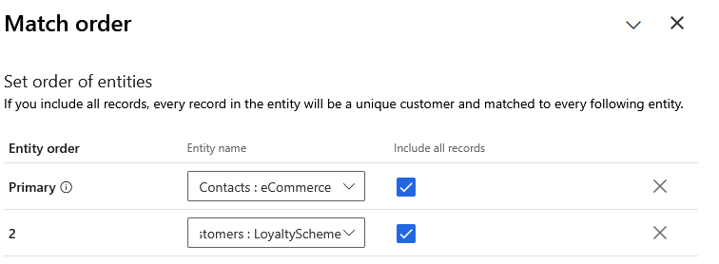

1. Click **Done**

## Task 3 – Create a Match Rule

In this step, you will create a simple rule used to match records together. Rules can consist of single (e.g. based on ID) or multiple conditions (e.g. Full Name, Postcode, Date of Birth).

For further details on Match Rules, please see [Customer Insights](https://docs.microsoft.com/en-us/dynamics365/ai/customer-insights/pm-match#step-two-define-rules-for-your-first-match-pair)) [documentation](https://docs.microsoft.com/en-us/dynamics365/ai/customer-insights/pm-match#step-two-define-rules-for-your-first-match-pair)).

1. Click **Add rule** or click the **+** button to the right of the ‘needs rule’ indicator.

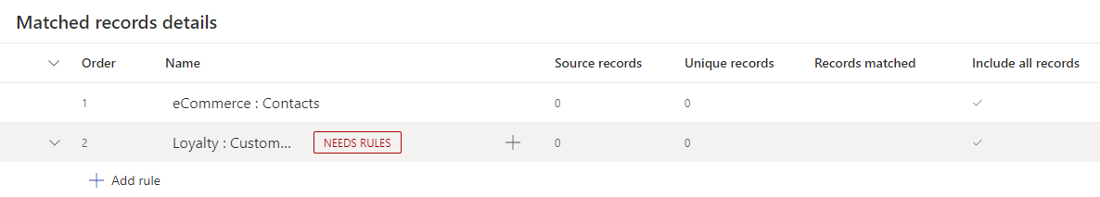

1. Add your first condition using FullName   
   **-** For entity **Contacts : eCommerce** select **FullName**

**-** For entity **Customers : Loyalty** select **FullName**

**-** Leave the **Normalize** blank.

**-** Set Precision Level to **Basic** and Precision value to **High**

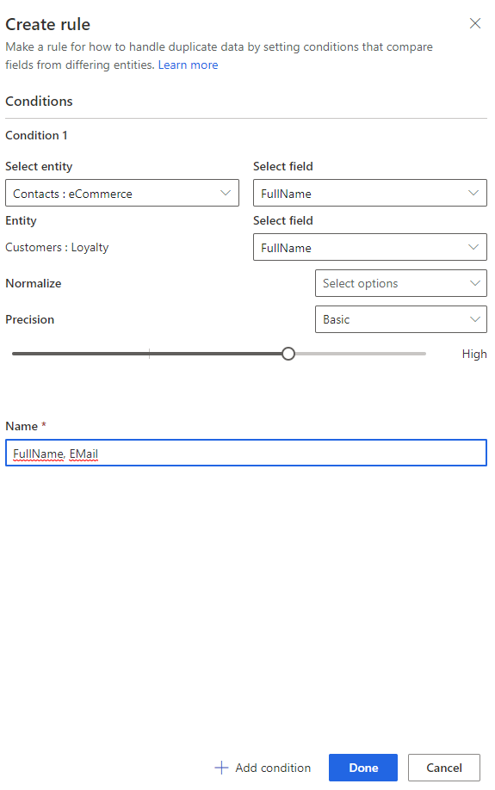

1. Enter the name **FullName, Email** for the new rule.
2. Add a second condition for email address by clicking **Add Condition**  
   **-** For entity **Contacts : eCommerce** select **Email**

**-** For entity **Customers : Loyalty** select **Email**

**-** Leave the **Normalize** blank.

**-** Set Precision Level to **Basic** and Precision value to **High**

Your match rule should now appear like the below. Click **Done.** 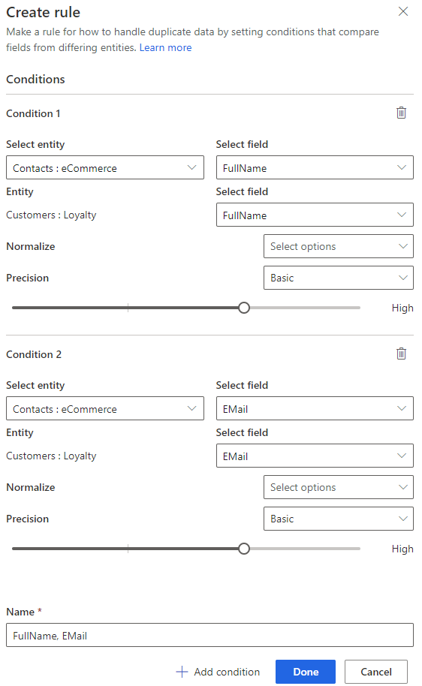

1. In the top left-hand corner click **Save** and then **Run.**

Customer Insights is now matching customer data from all your sources of customer information - to identify how many unique customer profiles you would have based on your rules

**How Many Unique Customers do you have when combining your datasets?**

## Task 4 – Precision

In Task 3, we used **High Precision** in the match-rule against Full Name. In this task, you will adjust the precision level, to create a higher number of matches, by including matches of a lower confidence (resulting in lower number of unique profiles).

**Notes on Precision -** Exact, on the right-side of the scale, will match records where your condition has an exact match. Select one of the other levels to match records that are not 100% identical. **High** fits cases where precision is more important than reach, such as a financial service to a specific customer. **Low** fits cases where the opposite is true, such as a marketing campaign. The Medium level serves as a middle-ground option.

1. Expand your rule and click the Graphical UIto edit the ‘Match’ Rule.

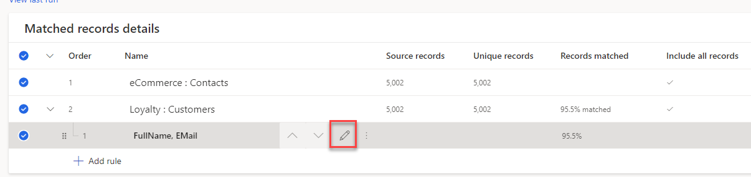

1. Move the Precision slider for your **FullName** match from **High** to **Low.** Then click **Done.**
2. Click **Save** and then **Run.**
3. Once the match process has completed, Open the **Match Preview** to see the match results and the **Confidence Score.** This shows how Customer Insights matched the data tables based on the rules you have defined. – You will notice that some profiles have been created with a low confidence of matching.

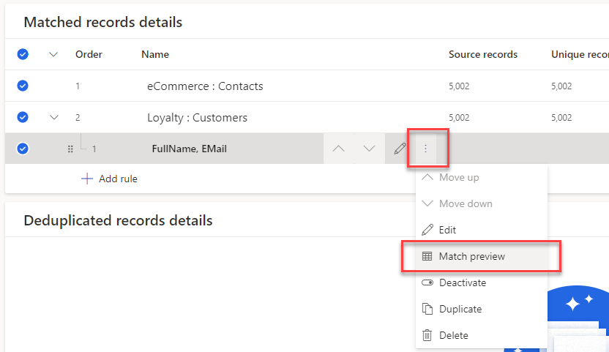

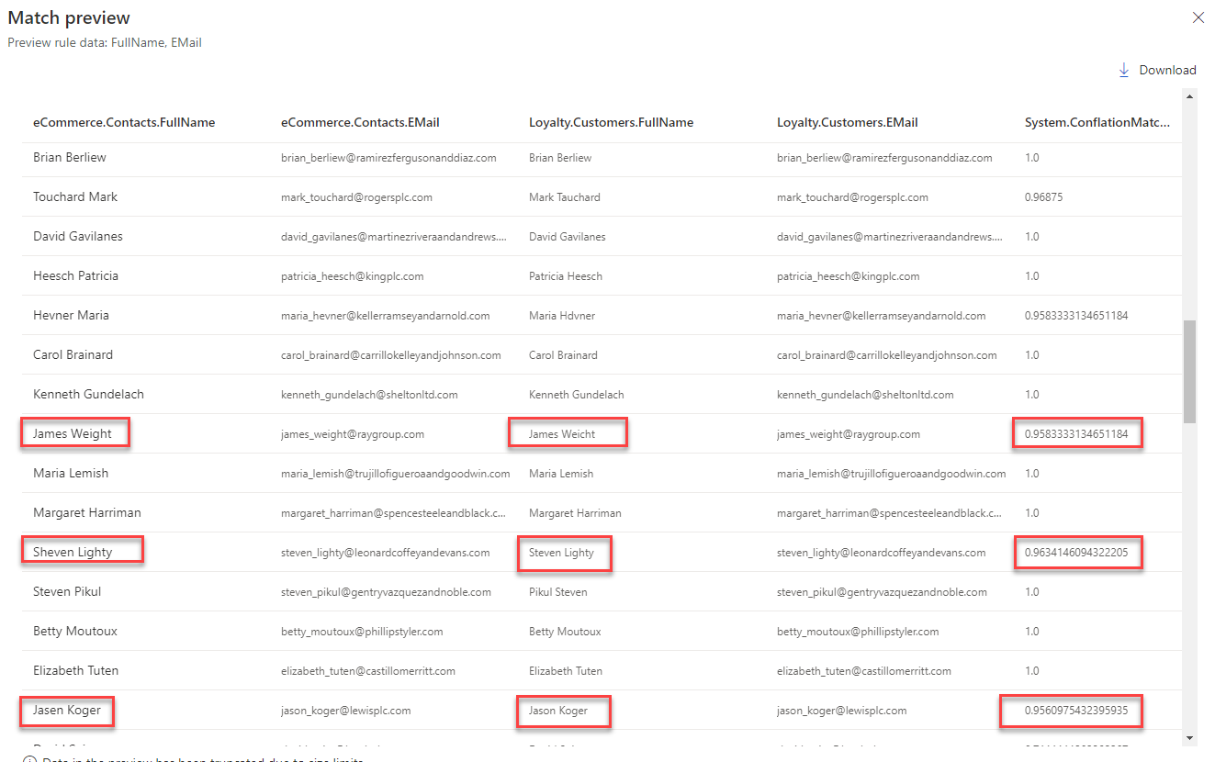

1. Close the preview and click the  to edit the match rule. Click the **Preview** button below the FullName rule.

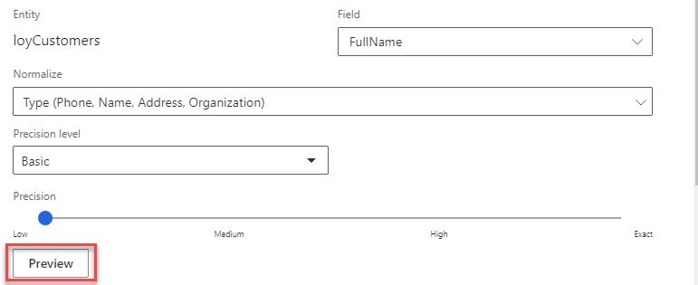

1. Here you can preview the number of Unmatched and Matched for your full name criteria. This screenshot shows that there were 52 Unmatched and 4950 Matched. ***Note:*** *Your number may be slightly different if the underlying data sources have changed since the docs were created or the matching algorithm has changed.*  
     
   Click **Preview Data** under **Unmatched** or **Matched** to preview the matches. Notice how High Confidence uses exact spelling but can match even if the name format (First Name, Last Name / Last Name, First Name) is different. With Low confidence, notice how matches are made even when names are not spelled identically.

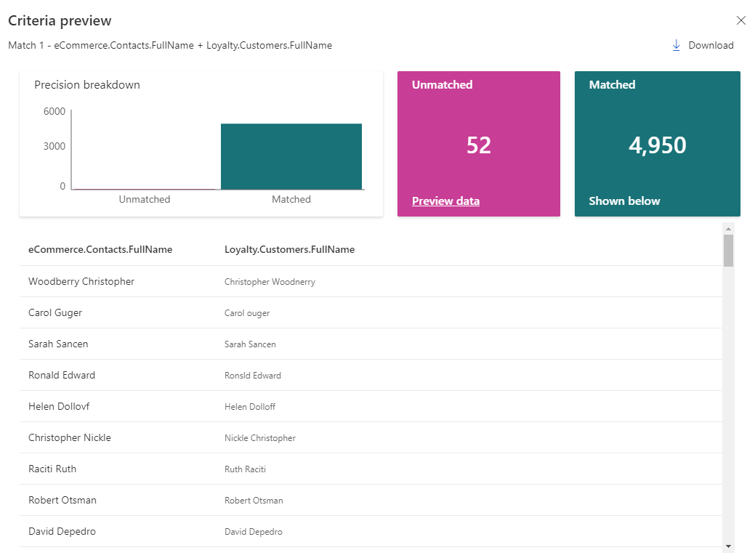

1. Close the Criteria Preview page. And click **Cancel**.

**How many Unique Customer Profiles do you have now?**

## Task 5 – Merge

The merge phase is the last phase in the data unification process. Its purpose is reconciling conflicting data and to define the attributes that will be used in your unified customer profile.

A Merged attribute is an attribute that exists in more than one data source and represents the same piece of data. For example, we may have ‘Email Address’ in both eCommerce Customers and Loyalty Customer data sources.

Customer Insights will attempt to identify attributes to be merged using their mapping to the standard data types we used in the **Map** stage.

1. Click **Merge.**

You will be presented with the **Merge** screen. Note that attributes from different sources that are of the same type (e.g. First Name) have been ‘Merged’.

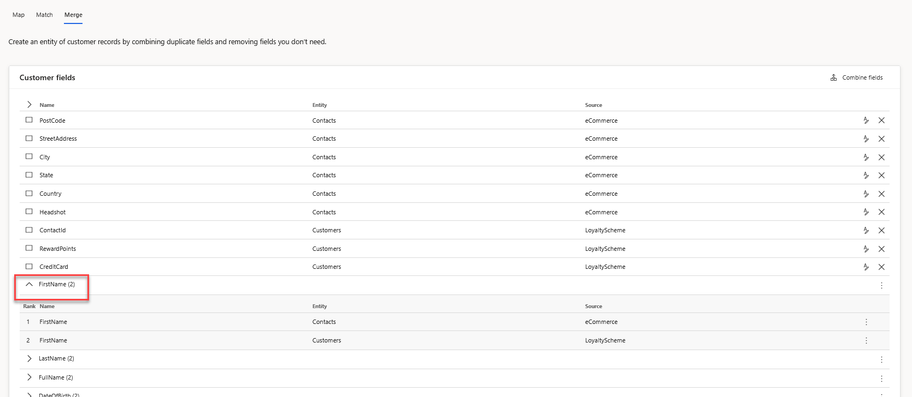

1. Click the  chevron on the **FirstName** merged attribute. You should see that the **FirstName** attribute in **eCommerce : Contacts** is ranked number 1. This denotes that where you have a matching customer profile in LoyaltyScheme and eCommerce, the **FirstName** taken from **eCommerce : Contacts** will be the primary.

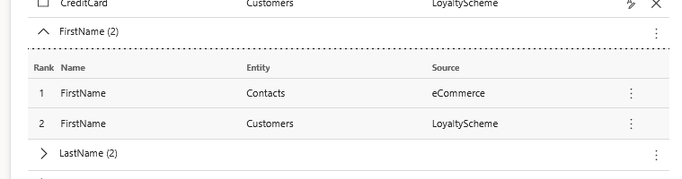

1. Click the 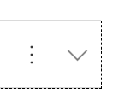 button on the row for the **FirstName** merged attribute and click **Edit.**Note that you’re able to change the display name and **importance rank** for the merged attribute. The **Display Name** is the name that will be used in the Merged Profile.

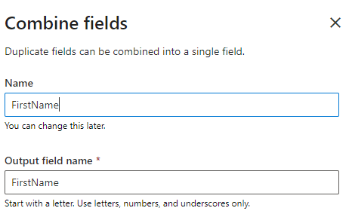 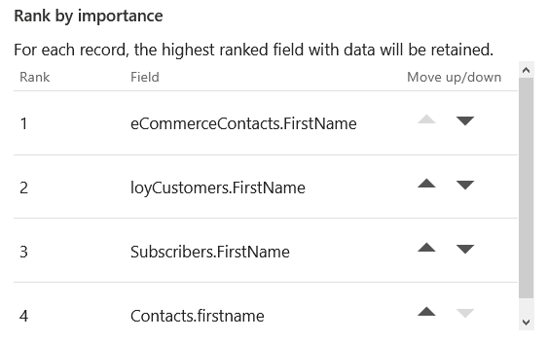

1. Click **Cancel.**
2. Note that the Primary Keys from the original sources cannot be merged. For example, we have a **ContactId** as the primary key from **eCommerce : Contacts** and we also have **ContactId** within **Loyalty : Customers**. In fact, we are merging these records not on ContactId, but on FullName & Email.
3. On the **ContactId** for the **Loyalty :** **Customers** Entity, click the edit button Graphical UI and rename the Display Name to **ContactIdLOYALTY** to differentiate the item from the other IDs ingested and help avoid any confusion later.

Graphical UI

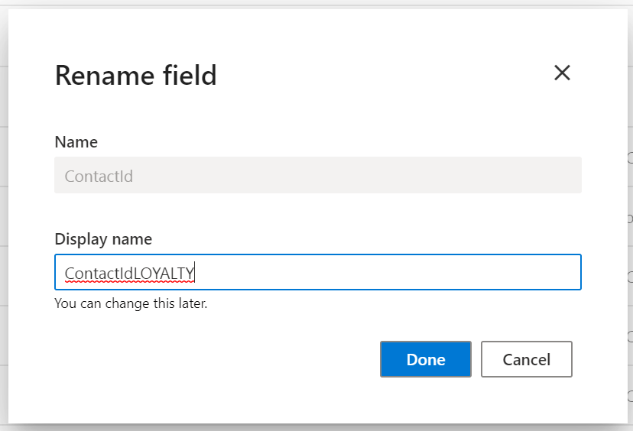

1. Click **Save** and **Run -> Run Merge and downstream processes** to start the Merge Process.

Congratulations! You have successfully Ingested, Mapped, Matched and Merged data from multiple sources within Customer Insights to create a Unified Customer Profile that can be used to gain insights into your whole customer base!

# Exercise 3 – Creating Relationships and Measures

Overview of Relationships & Measures

Before creating a measure, we need to understand the purchases made by a customer both online and instore. To do this we need to define the relationship between Purchases (made online and in store) and the Unified Customer Profile.

Relationships help you connect entities and generate a graph of your data. Relationships are used when entities share a common identifier (foreign key) that can be referenced from one entity to another. Connected entities enable you to define segments and measures based on multiple data sources.

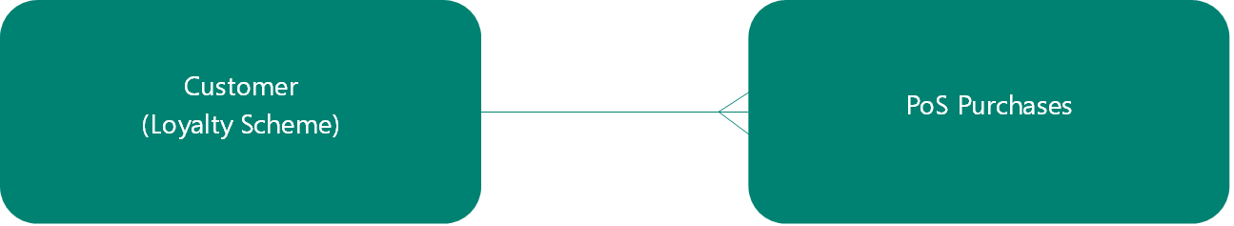

For example, Customer has a One to Many relationships with PoS Purchases. (One loyalty scheme customer may make multiple purchases). – This is an example of the relationship we will be defining.

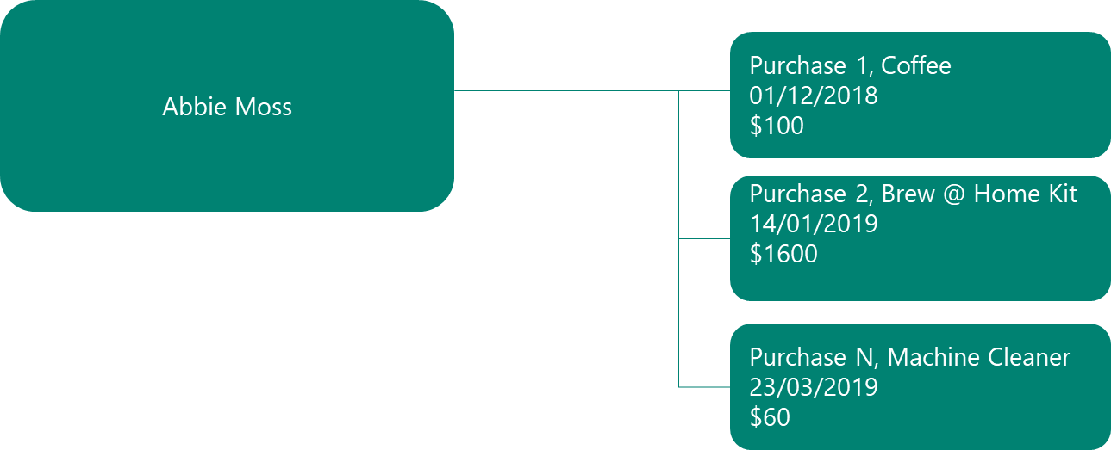

### Measures

Measures enables you to define all the key performance indicators (KPIs) that best reflect your specific business performance and health. Measures can either be customer-related measures such as Lifetime Value or business-health measures such as Monthly Active Users.   
  
Customer Insights provides an intuitive experience to build different types of measures, with a query-builder wizard that doesn’t require the user to manually code or validate the query.

Measures are calculated on a series of interactions that a company has with a customer, gathered from multiple data sources. Interactions are any customer touch points – these could include purchases, customer service cases, emails, phone calls, branch visits. In other scenarios interactions could also be data gathered from connected devices, withdrawals, or deposits in banking, entry/exist of a premises or area etc.

Contoso Coffee are looking to uncover six simple **Measures** based on the data ingested, that will help them to identify high-value customers and their preferred purchase method (Online or Instore)  
  
**Business Measures:**

* **Average Store Purchase Value ($)**
* **Average Web Purchase Value ($)**

**Customer Attribute:**

* **Lifetime Spend ($)**
* **Total Club Points**
* **Average Store Purchase ($)**
* **Average Web Purchase ($)**

## 

## Task 1 – Define the Relationship Between Unified Profiles and Web Purchases

Define the relationship for **CustomerPurchasesEcom**

1. Under **Data** within the left-hand menu, click **Relationships** in the left-navigation menu
2. Click **New Relationship**
3. Name the relationship **CustomerPurchasesEcom**
4. In **Description** add **Online Purchases to Unified Customer Profile**
5. Set **Source** details entity to **Purchases: eCommerce** and **Cardinality** to **Many**
6. Set Target details entity to **Customer : CustomerInsights** and Cardinality to **One**
7. Set equivalent fields to **ContactId** for both the **Source** and **Target** fields.
8. Click **Save**

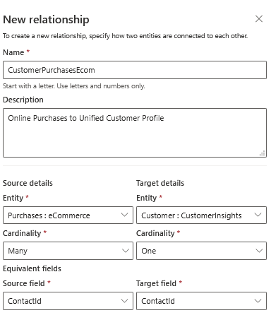

## Task 2 – Define the Relationship between Unified Profiles and Store Purchases

Define the relationship for **CustomerPurchasesPOS**

1. Under **Data** within the left-hand menu, click **Relationships** in the left-navigation menu
2. Click **New Relationship**

Name the relationship **CustomerPurchasesPOS**

1. In **Description** add **Point of Sale Purchases to Unified Customers**
2. Set **Source** details entity to **Purchases : PoS** and **Cardinality** to **Many**
3. Set Target details entity to **Customer : CustomerInsights** and Cardinality to **One**
4. Set equivalent fields to **LoyaltyId** for both **Source field** and **Target field**
5. Click **Save**

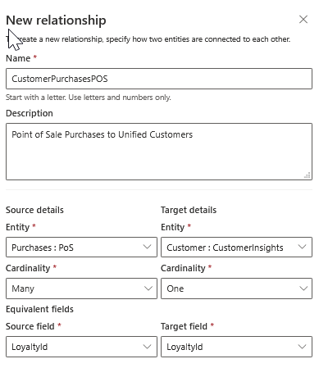

You should now have the following relationships defined

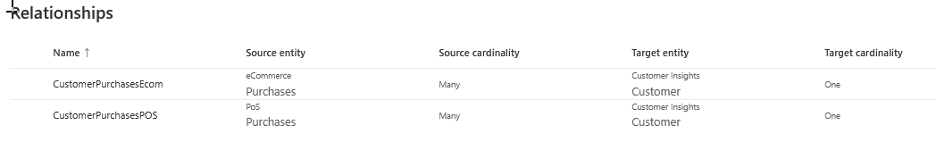

## Task 3 – Define Two Business Measures

Business Measures helps you track your business performance and health.   
Examples: **Average Sales per Customer** and **Monthly Active Users (MAU).**

The business has asked you to calculate the **Average Store Purchase** and **Average Web Purchase** values for the Contoso Coffee business.

### Average Store Purchase Value (Business Measure)

*Average value of all in store purchases made at Contoso Coffee*

1. Click **Measures** on the left-hand menu.
2. Click the **New** buttonin the top left-hand corner, then **Build your own**.
3. Next to the **Untitled measure** text, select **Edit name.**

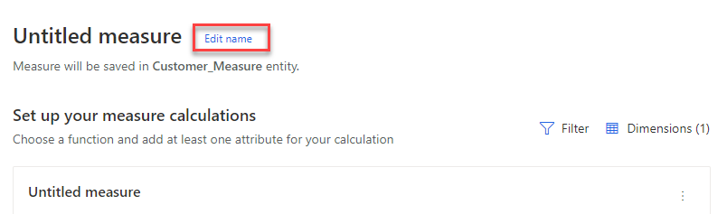

1. Set the name to **Average Store Purchase Value ($)**,select **Done.**

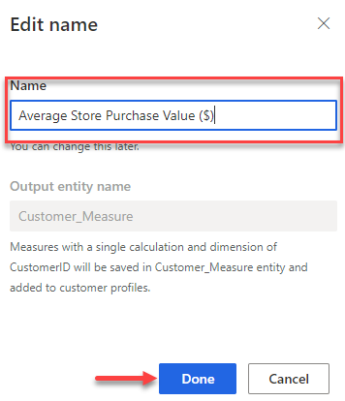

1. Under **Set up your measure calculations**, select **Dimensions (1).**

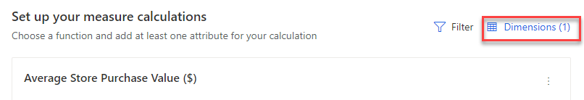

1. Delete **Customer: CustomerInsights.CustomerId** and select **Apply**. *(By deleting the customer dimension, these changes the measure from a customer measure to a business measure).*

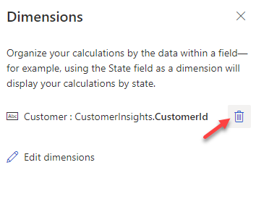

1. Next to **Calculation 1**, click **Edit name**
2. Set the Display name to **Average Store Purchase Value ($)**.
3. Verify the Attribute name is set to **AverageStorePurchaseValue.**

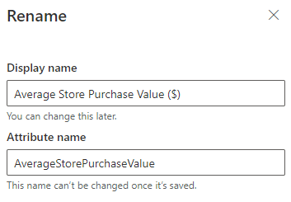

1. Select **Done**.
2. Under the **Average Store Purchase Value ($)** calculation, click **Select Function** and choose **Average**.

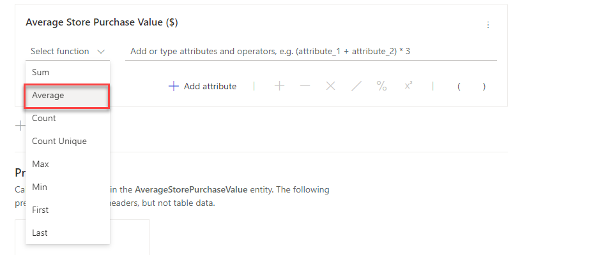

1. Select **Add attribute**, expand **Purchases : PoS**, and select **TotalPrice**.

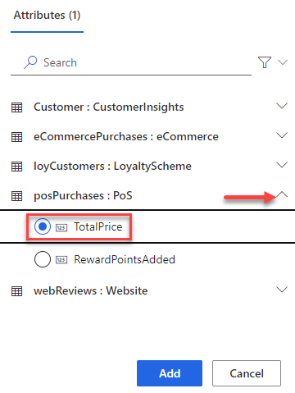

1. Select **Add**.
2. Select the **Run** button to complete your measure.

### Average Web Purchase Value (Business Measure)

*Average value of all web purchases made at Contoso Coffee*

1. Click **Measures** on the left-hand menu.
2. Click the **New** buttonin the top left-hand corner, then **Build your own**.
3. Next to the **Untitled measure** text, select **Edit name.**



1. Set the name to **Average Web Purchase Value ($)**,select **Done.**

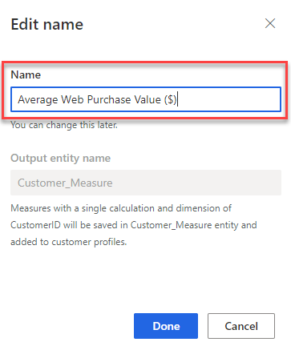

1. Under **Set up your measure calculations**, select **Dimensions (1).**



1. Delete **Customer: CustomerInsights.CustomerId** and select **Apply**. (By deleting the customer dimension, these changes the measure from a customer measure to a business measure)



1. Next to **Calculation 1**, click **Edit name**
2. Set the Display name to **Average Web Purchase Value ($)**
3. Verify the Attribute name is set to **AverageWebPurchaseValue.**

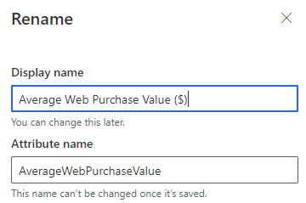

1. Select **Done**.
2. Under the **Average Web Purchase Value ($)** calculation, click **Select Function** and choose **Average**.



1. Select **Add attribute**, expand **Purchases : eCommerce**, and select **TotalPrice**.

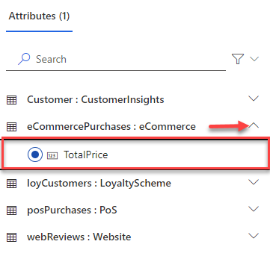

1. Select **Add**.
2. Select the **Run** button to complete your measure.

## Task 4 – Define Customer Measures

We will need two customer measures that can be used to calculate a customer attribute. We will create one measure to determine the customers total spend on Online Purchases and one measure to determine their total spend on In-Store purchases. Once we create these, we can then create a customer attribute to add those two together.

### Total In-Store Spend (Customer Measure)

*Total of all purchases made online*

1. If necessary, click **Measures** on the left-hand menu.
2. Click the **New** buttonin the top left-hand corner, then **Build your own**.
3. Next to the **Untitled measure** text, select **Edit name.**
4. Set the name to **Total In-Store Spend**,select **Done.**
5. Under the **Total In-Store Spend** calculation, click **Select Function** and choose **Sum**.
6. Select **Add attribute**, expand **Purchases : POS**, select **TotalPrice**, and click **Add.**
7. Under **Set up your measure calculations**, select **Dimensions (1).**
8. Select **Edit Dimensions**
9. Expand **Purchases: PoS**, select **LoyaltyID**, and click **Done**.

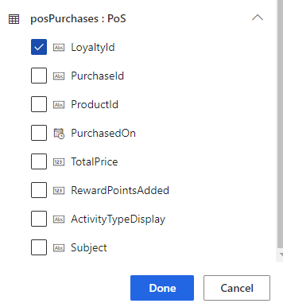

1. Click **Apply**
2. Select the **Run** button to complete your measure.

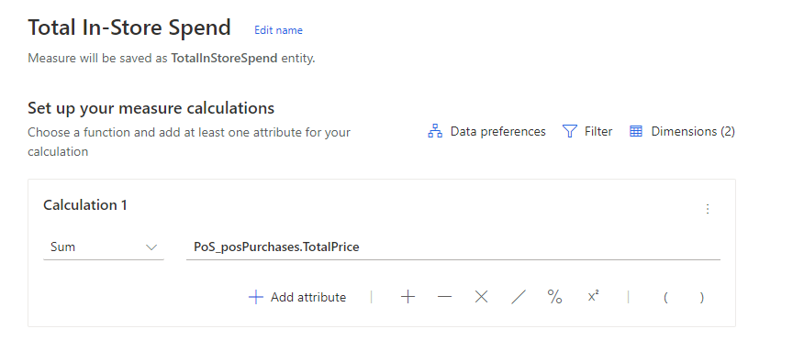

Total Online Spend (Customer Measure)

*Total of all purchases made in store*

1. In Necessary, click **Measures** on the left-hand menu.
2. Click the **New** buttonin the top left-hand corner, then **Build your own**.
3. Next to the **Untitled measure** text, select **Edit name.**
4. Set the name to **Total Online Spend**,select **Done.**
5. Under the **Total Online Spend** calculation, click **Select Function** and choose **Sum**.
6. Select **Add attribute**, expand **Purchases: eCommerce**, select **TotalPrice** and click **Add.**
7. Under **Set up your measure calculations**, select **Dimensions (1).**
8. Select **Edit dimensions**
9. Expand **Purchases: eCommerce**, select **ContactId**, and click **Done**.

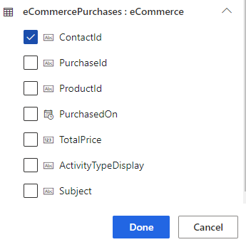

1. Click **Apply**
2. Select the **Run** button to complete your measure.

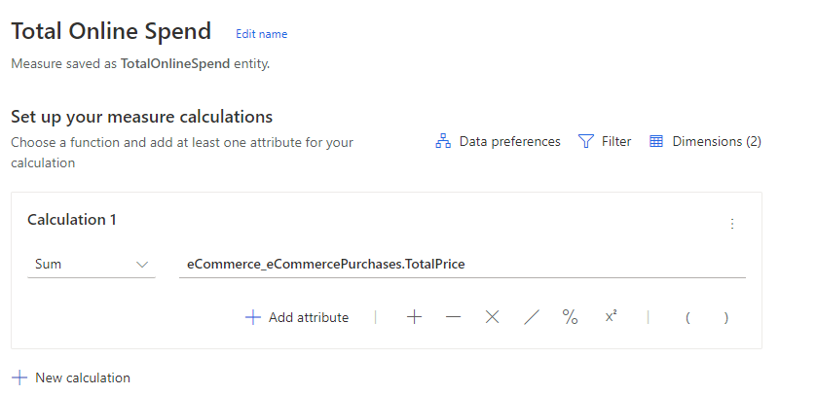

## Task 5 – Define Customer Attributes

Customer Attributes are a single field per customer that reflects a score, value, or state for each customer. Examples are **Lifetime Value**and **Total Sales.**

In this task you will create measures to calculate the **Lifetime Spend ($), Total Club Points, Average Web Purchase Value ($)** and **Average Store Purchase Value ($)** of each customer. By calculating value for the business and customers, Contoso Coffee can identify customers with a higher than average spend on each channel.

Total Club Points (Customer Attribute)

*Total Loyalty Points earned by each customer*

1. If necessary, click **Measures** on the left-hand menu.
2. Click the **New** buttonin the top left-hand corner, then **Build your own**.
3. Next to the **Untitled measure** text, select **Edit name.**
4. Set the name to **Total Club Points**,select **Done.**
5. Under the **Total Club Points** calculation, click **Select Function** and choose **Sum**.
6. Select **Add attribute**, expand **Purchases : POS,** select **RewardPointsAdded** and click **Add**.
7. Select the **Run** button to complete your measure.

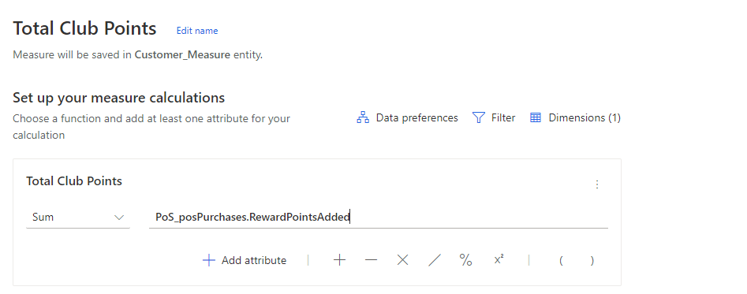

Lifetime Spend (Customer Attribute)

*Total value of all purchases made for each customer*

1. If necessary, click **Measures** on the left-hand menu.
2. Click the **New** buttonin the top left-hand corner, then **Build your own**.
3. Next to the **Untitled measure** text, select **Edit name.**
4. Set the name to **Lifetime Spend ($)**,select **Done.**
5. Under the **LifetimeSpend** calculation, click **Select Function** and choose **Sum**.
6. Select **Add attribute**.
7. Select **Measures**, expand **TotalInStoreSpend : CustomerInsights**, select **Calculation 1,** and select **Add**.

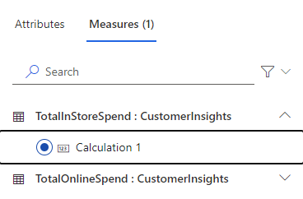

1. Select the **Plus Sign** icon next to Add Attribute
2. Select **Add attribute**.
3. Select Measures, expand **TotalOnlineSpend : CustomerInsights**, select **Calculation 1,** and select **Add**.

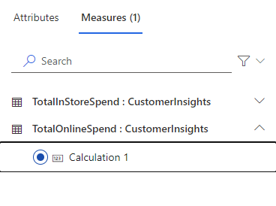

1. Select the **Run** button to complete your measure.

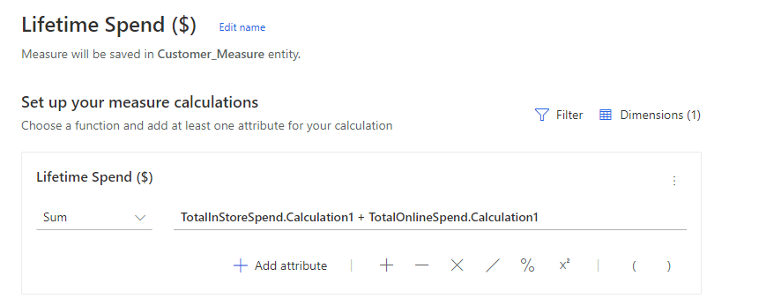

Average Store Purchase (Customer Attribute)

*Average value of all store purchases made for each customer*

1. If necessary, click **Measures** on the left-hand menu.
2. Click the **New** buttonin the top left-hand corner, then **Build your own**.
3. Next to the **Untitled measure** text, select **Edit name.**
4. Set the name to **Average Store Purchase ($)**,select **Done.**
5. Under the **Average Store Purchase** calculation, click **Select Function** and choose **Average**.
6. Select **Add attribute**, expand **Purchases : PoS** select **Total Price,** and click **Add**.
7. Select the **Run** button to complete your measure.

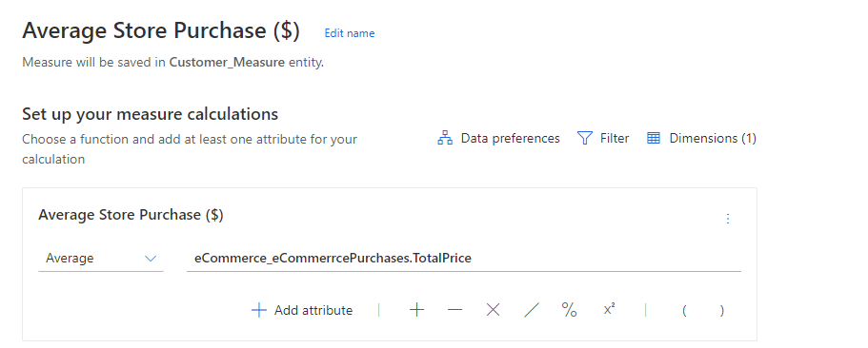

Average Web Purchase (Customer Attribute)

*Average value of all web purchases made for each customer*

1. If necessary, click **Measures** on the left-hand menu.
2. Click the **New** buttonin the top left-hand corner.
3. Next to the **Untitled measure** text, select **Edit name.**
4. Set the name to **Average Web Purchase ($)**,select **Done.**
5. Under the **Average Web Purchase ($)** calculation, click **Select Function** and choose **Average**.
6. Select **Add attribute**, expand **Purchases : eCommerce**, select **Total Price** and click **Add**.
7. Select the **Run** button to complete your measure.

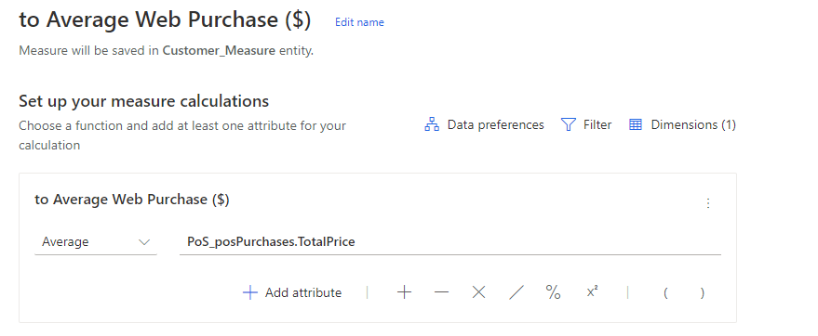

## Task 6 – Review the Measures

1. Make sure all your measures have successfully refreshed, then navigate to the Customer Insights Home Page. You should notice that your Business Measures are visible on the home page.

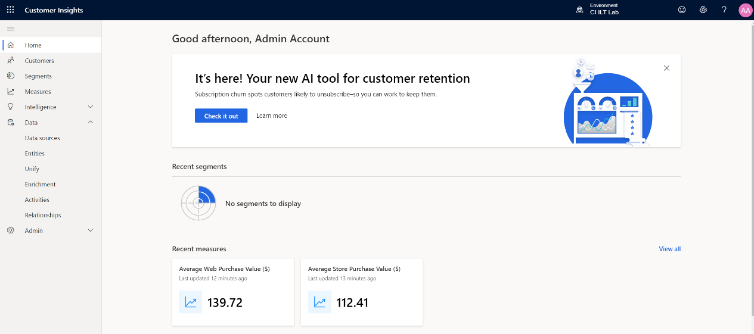

1. Navigate to the **Data** **-> Entities** menu area and open the **Customer_Measure** entity.

You should be presented with a preview of the Customer Measures you have calculated against the Unified Profile Customer ID. Click on the **Data** tab to see the results.  
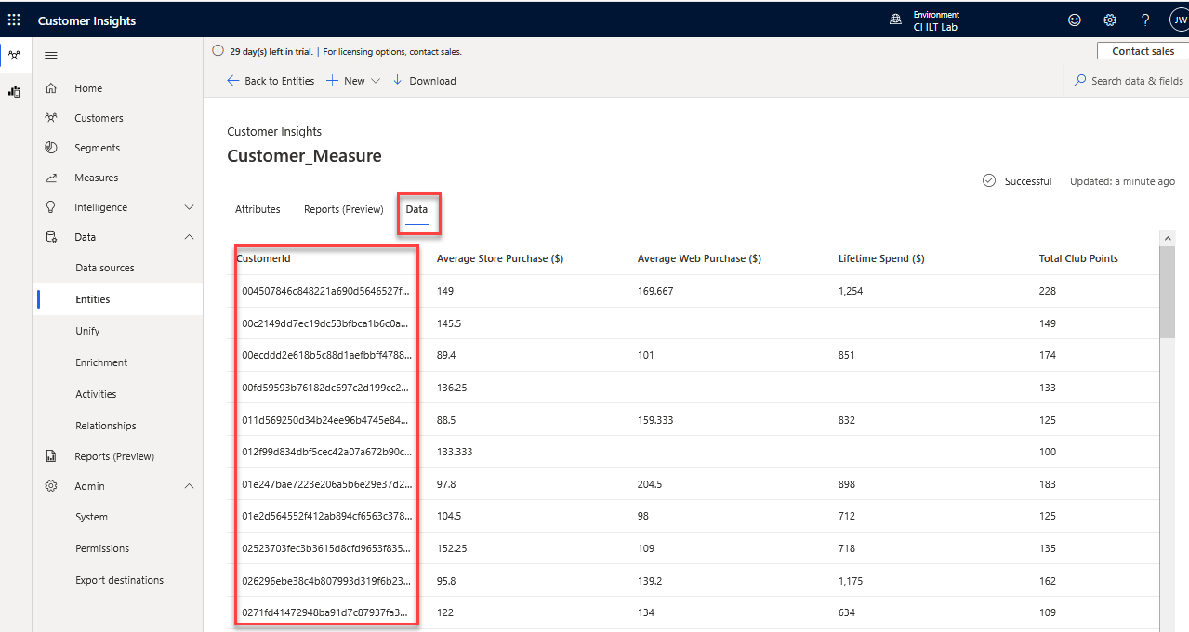

One interesting view to explore is the Summary view for the measures. From the screen above click on the **Attributes** tab just below the page heading (highlighted above), then click on the Summary chart icon Graphical UI for **Total Club Points**. You should get a pop-up like this with some useful stats about the measure.

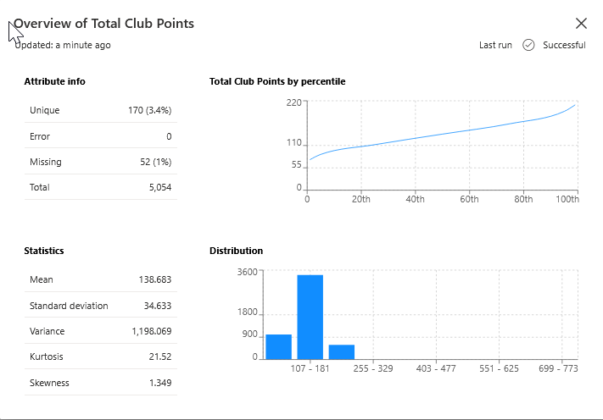

You are now able to consume these measures to drive action such as **Marketing Segments**.